Cancel Order as Student

Document Information

|  |  |
| --- | --- |
| **Document Title** | Title of use case – Verb Noun phrasing is almost always the most appropriate! |
| **Document Owner** |  |
| **Version** |  |
| **Status** |  |
| **Date** |  |

1. Brief Description

This use case allows a student to cancel an order before a specified time and have the canceled amount added back to their account.

1. Actors

* Student

1. Trigger

The student decides to cancel their order.

1. Pre-Conditions

* The student must be logged into the system.
* The student must have an existing order.
* The cancellation request must be made before the specified time.

1. Post-Conditions

* The order status is updated from “confirmed” to "canceled".
* The canceled amount is added back to the student's account balance.

1. Basic Flow
2. The student logs in to the system.
3. The student navigates to “My Order” section.
4. The system displays a list of orders made by the student.
5. The student selects the order which is available to be cancelled.
6. The student selects the "Cancel" option.
7. The system prompts a message to confirm with the student that they want to cancel the order.
8. The student selects “Agree” button to confirm cancelling the order.
9. The system updates the order status from “confirmed” to “cancelled”.
10. The system adds the canceled amount back to the student's account balance.
11. The system displays the updated account balance to the student.
12. The system returns the student to “My Order” page.
13. Alternate Flows
14. Exception Flows

* 4a. If the student selects the order after the specified time for canceling orders, the system displays a message informing the student that it is too late to cancel the order. Return to step 3.
* 7a. If the student selects “Agree” button after the specified time for canceling orders, the system displays a message informing the student that it is too late to cancel the order. Return to step 3.
* 7b. If the student wants to cancel the order cancellation, select “Cancel” button.

1. Business Rules

* The specified time for canceling orders should be 1 day before the ordered day.
* The amount refunded for a canceled order should be equal the order amount.

1. Non-Functional Requirements

* The system should process the cancellation and refund quickly to prevent delays for other users (1s).
* The system should provide clear and concise messaging to the student throughout the cancellation process.

1. Supplemental Requirements
2. Visual Model

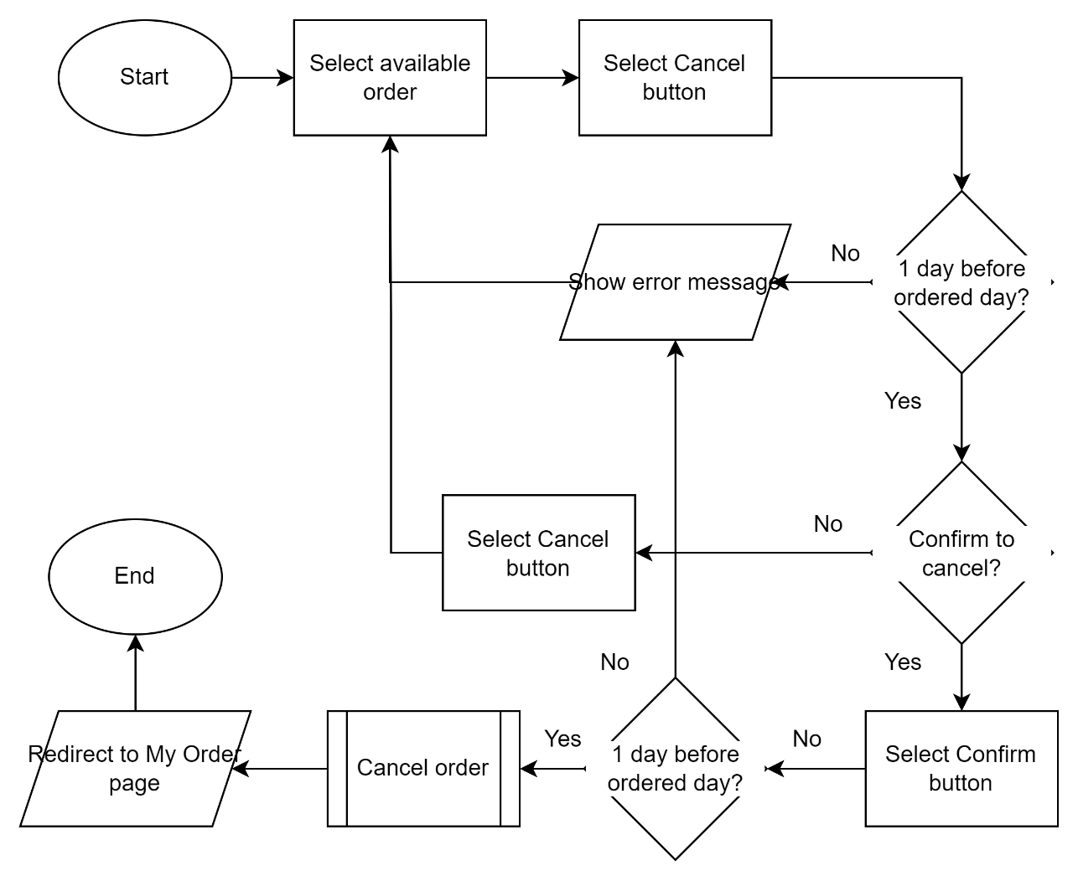

Revision History

|  |  |  |  |  |
| --- | --- | --- | --- | --- |
| V. | Date | Author | Description | Status |
|  |  |  |  |  |
|  |  |  |  |  |